Source: https://algs4.cs.princeton.edu/11model/
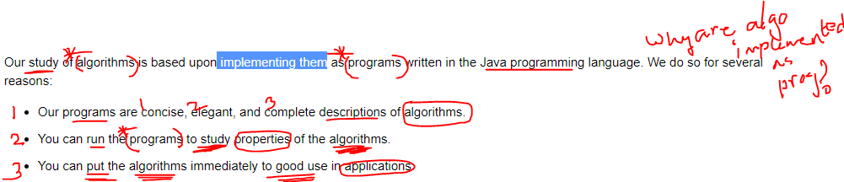
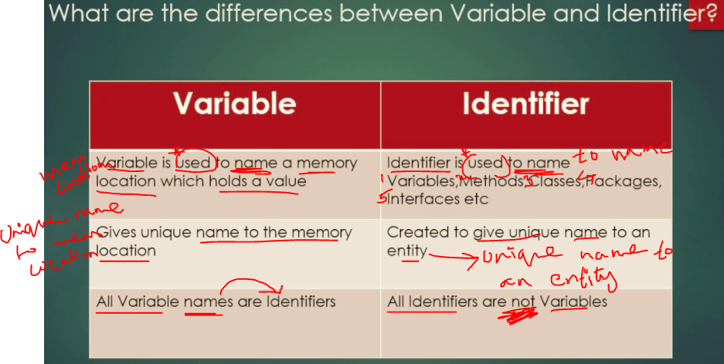
Source : https://www.math.uni-hamburg.de/doc/java/tutorial/java/nutsandbolts/expressions.html
Go to that website to learn about Expressions, Statements and Blocks

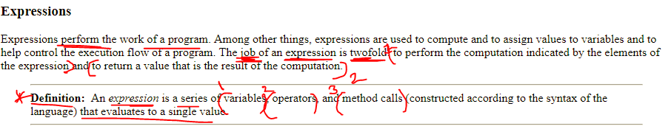

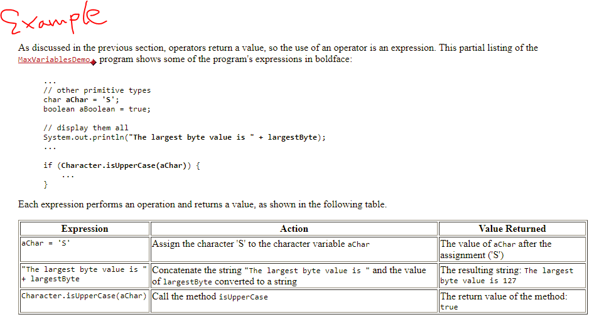

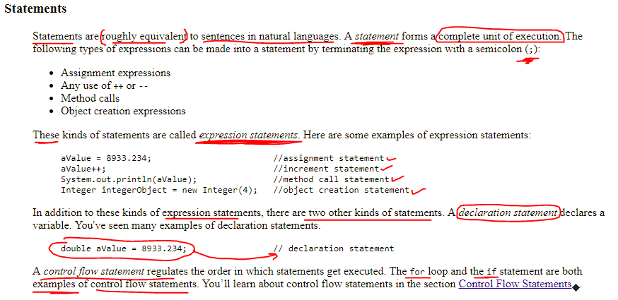
Source: https://docs.oracle.com/javase/tutorial/java/nutsandbolts/datatypes.html

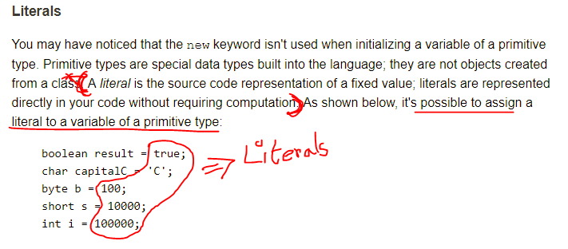
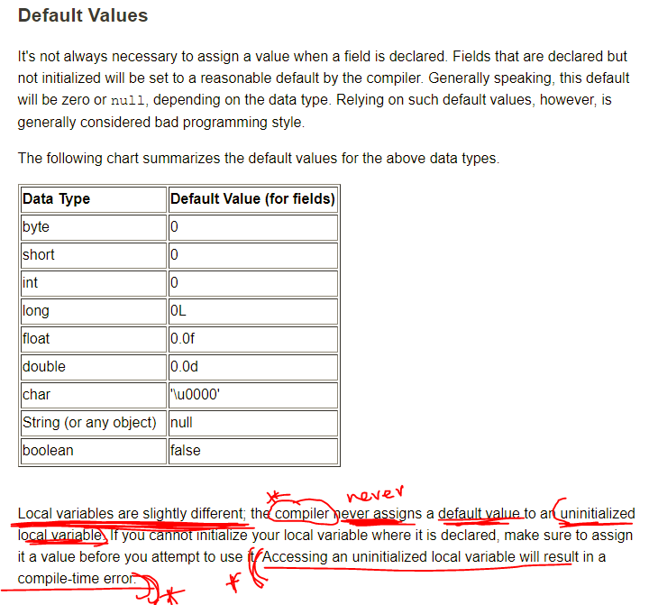
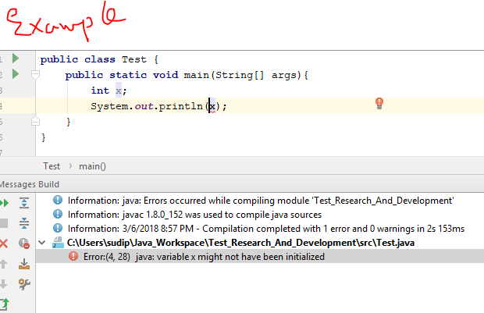

Source: https://algs4.cs.princeton.edu/11model/
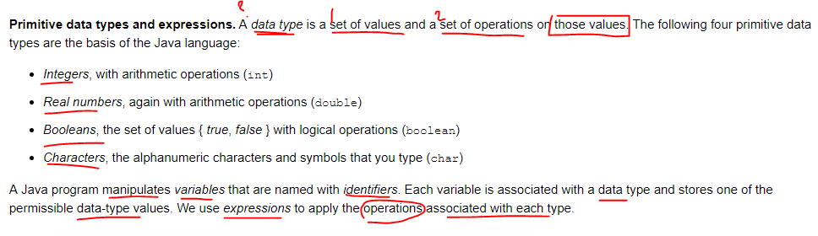
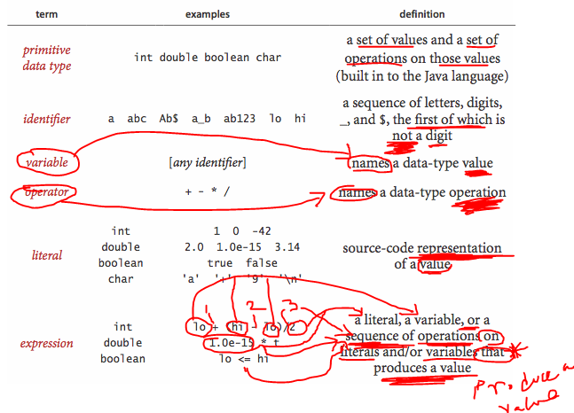
_ and $ signs are the only special characters an identifier can have
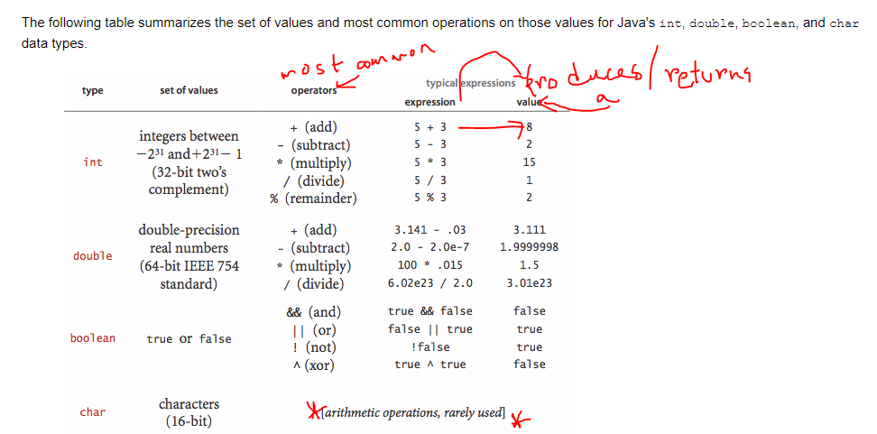

Source: http://www.cs.man.ac.uk/~pjj/cs212/fix.html
Infix, Prefix and Postfix expressions. You can read about them in the above link.
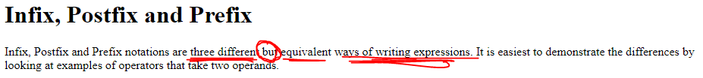
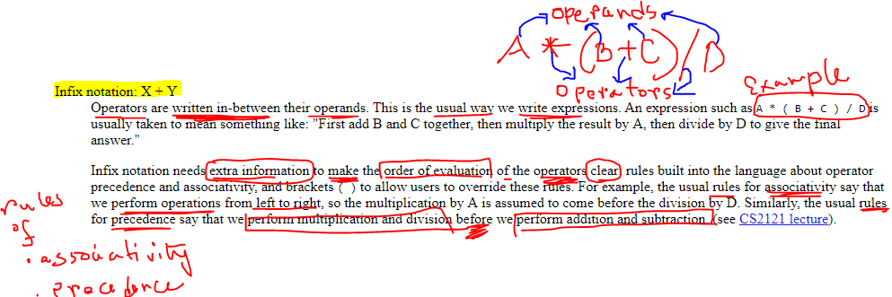
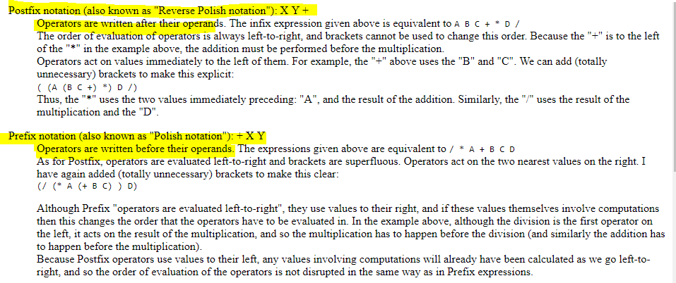
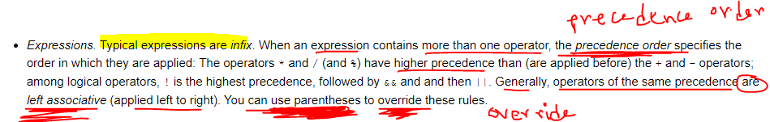
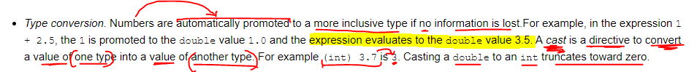
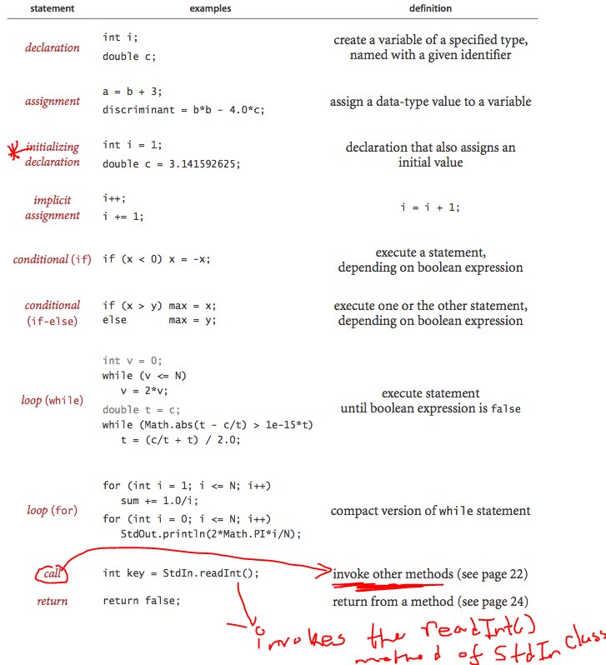
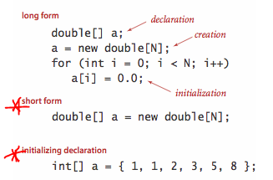
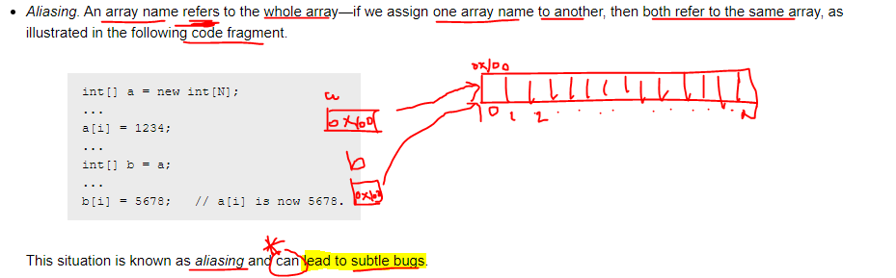
METHOD SIGNATURE
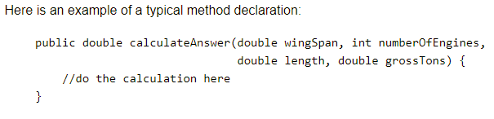
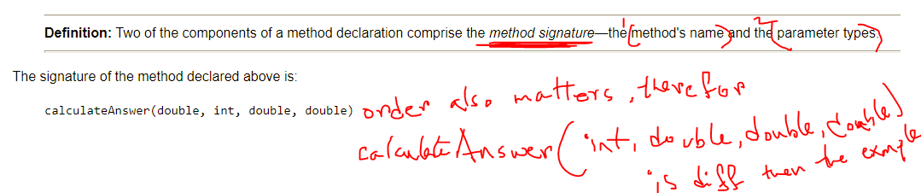
The return type is not part of the method signature.

Method Signature is part of the Method declaration.
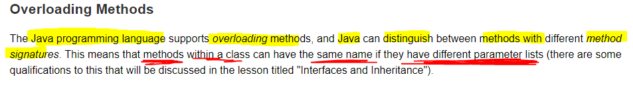
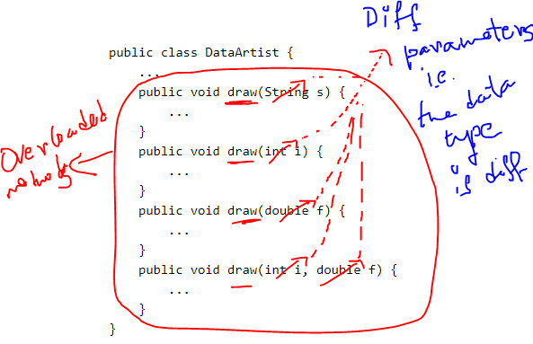
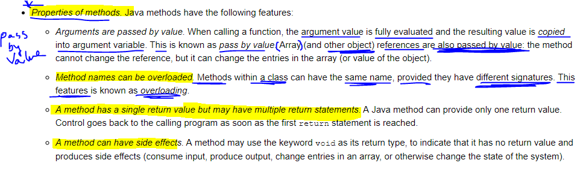
Properties of Java Method:
Pass By Value
Overloaded
Single return value but multiple return statements
Can have side effects
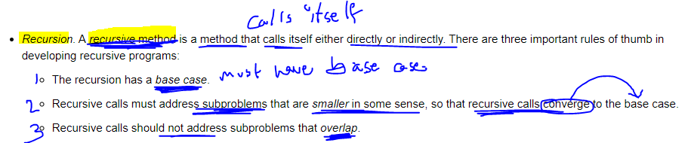
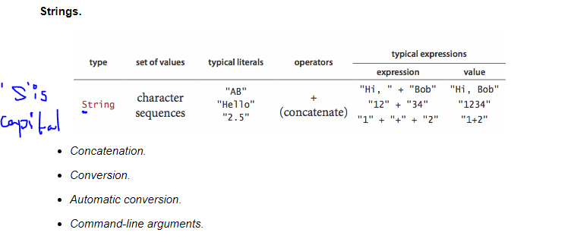
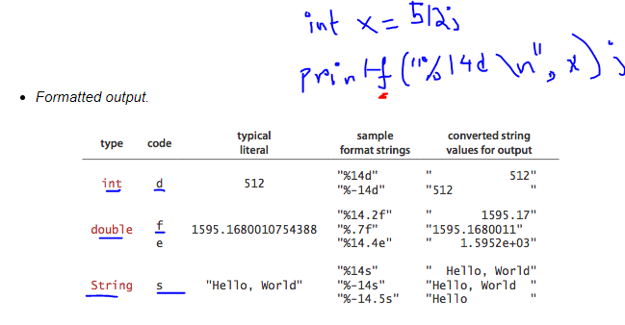
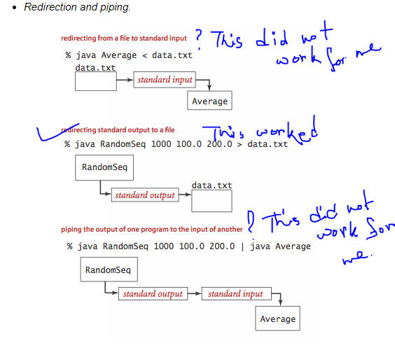
How to Compile and Run Java Programs that uses external jar files, for example the algs4.jar?
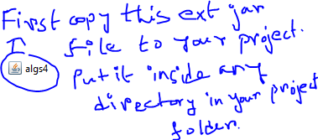
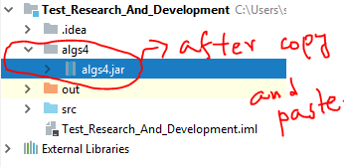

Here is the stackoverflow link that answers the above question:
https://stackoverflow.com/questions/8949413/how-to-run-java-program-in-terminal-with-external-library-jar/8949442
